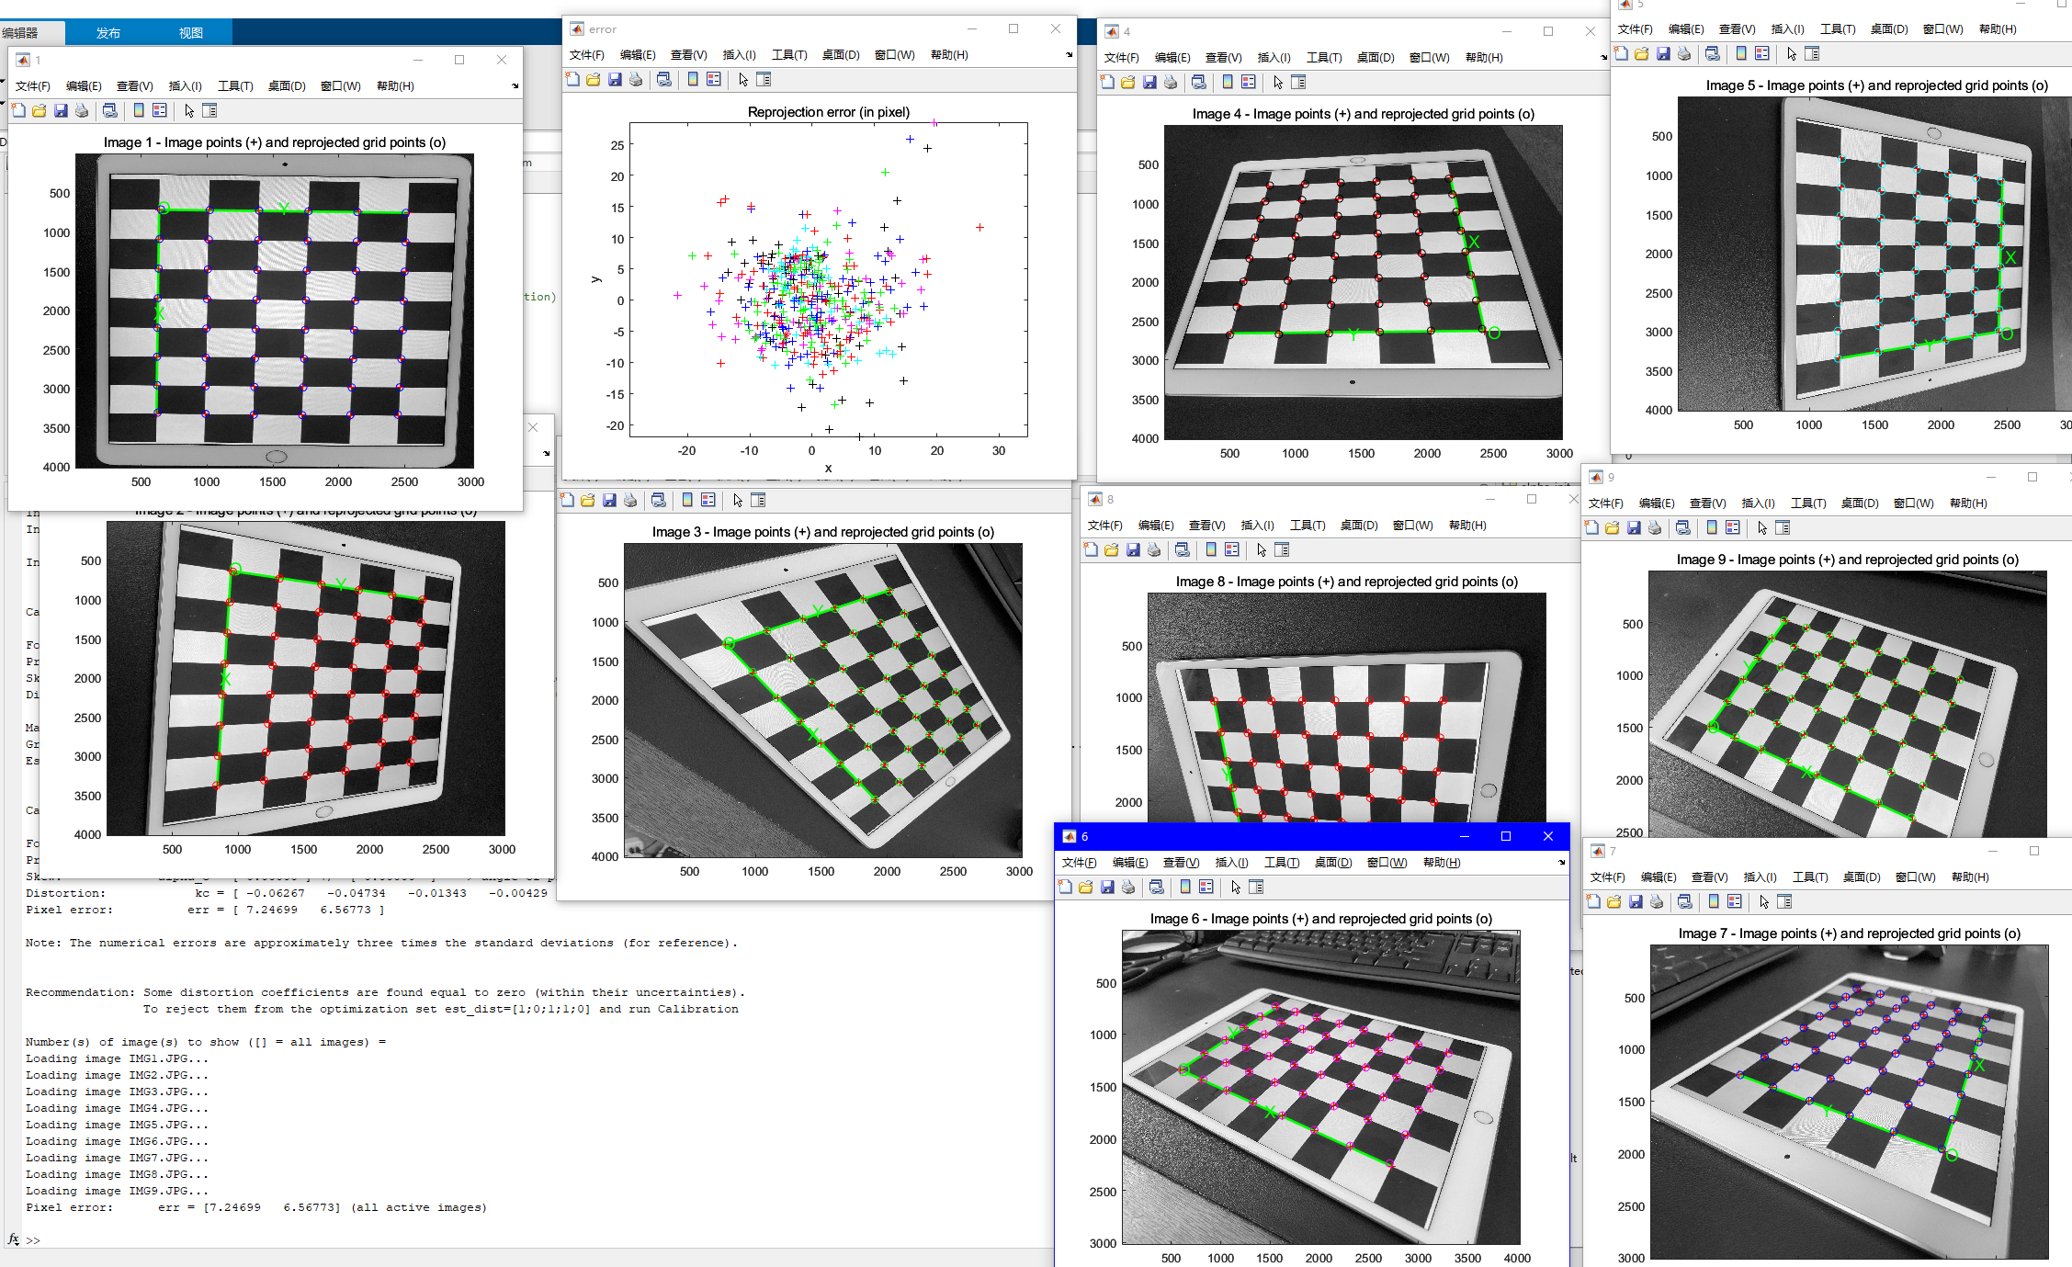

Pixel error: err = [7.24699 6.56773] (all active images)

After changing from 4000 x 3000 to 1600 x 729, the reproj error came to be a reasonable value of

Pixel error: err = [0.49564 0.75135] (all active images)

After Calibration Before Calibration

The image of LSC and the final mosaic is in the LSC folder

Some sample image is as follows:

And the stitched image is as follows:

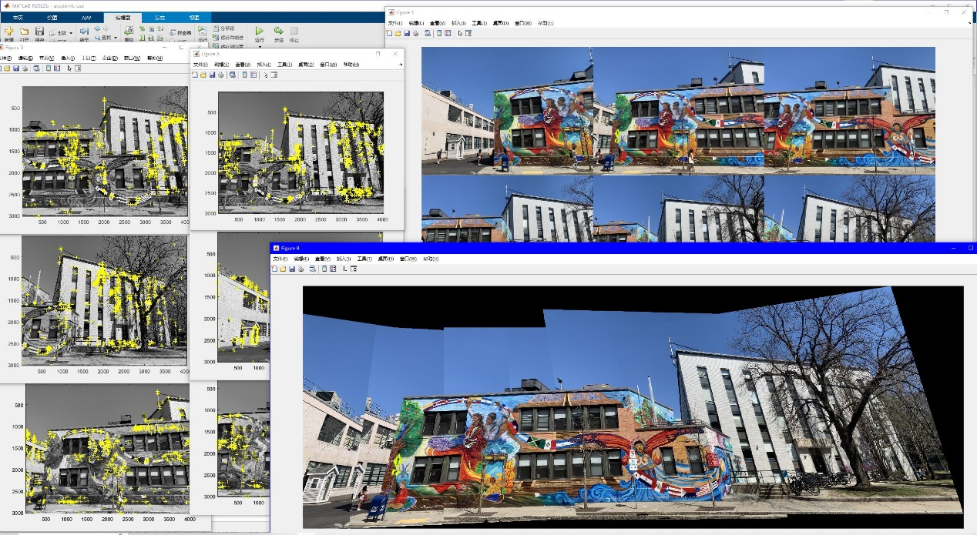

In the process of using the feature-based panoramic image stitching, I set the detector with 1000 features, and with a 2 by 2 tile that distributes these feature points across the image

The corner detection is working properly but has some drawbacks as can be seen on the stitched image, there are several places where the pattern slightly misaligns. This is mainly due to that harris struggles to detect 3D objects and structures through 2D detectors.

I couldn’t finish the following within the deadline, I will try to finish this sometime later if allowed.